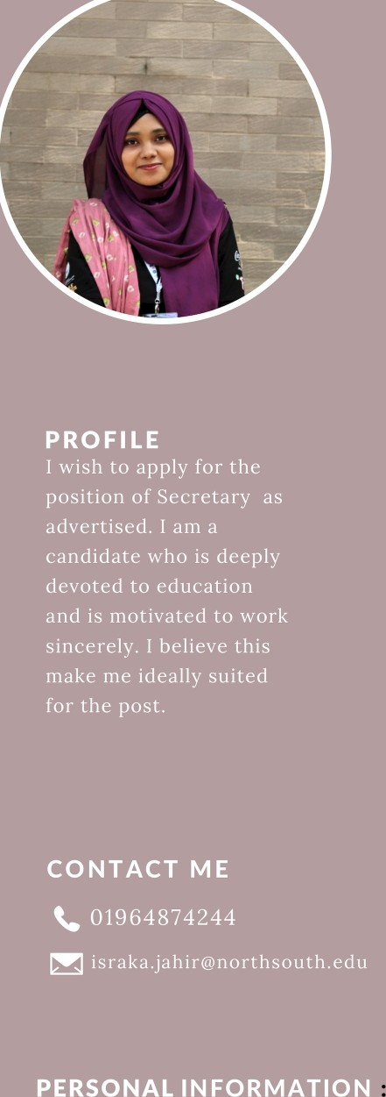I RAKA

IR

Under prndonte Student

# EDUCATION

NORTH SOUTH UN I VE RS I TY

Bs c in Com pute r S cie n ce and Esq in eerinq Credits co mplete d: 128.5

Current CGPA: 3.69

M I L ESTO N E CO LL E G E

HS C:4.87 SS C: 5

# LANGUAGE

Engli sh. Bangla

S KI LL H IG H LIG H TS

Programming languages: C, C++, SQL Web and scripts: HTML, CSS Database: MyS QL

Proficient in using Word and PowerP oint and Exce1

Responsibl e, punctual, honest, adaptable and sincere

# EXP ERI E NCE

Working as an undergraduate teacher assistant since Summer-22.